**Techniques of Molecular Biology**

1.Electrophoresis

2.Restriction digestion

3.Hybridization

4.PCR

5.Genome sequence & analysis

6.DNA Cloning and gene expression

Gel electrophoresis separates DNA and RNA molecules according to size shape and topological properties

**To separate DNA of different size ranges**

Narrow size range of DNA: use polyacrylamide

Wide size range of DNA: use agarosegel

Very large DNA(>30-50kb): use pulsed-field gel electrophoresis

**Southern/Northern/Western Blotting, those techniques for what’s purpose ?**

**Southern Blotting** detects the target gene in genome

**Northern Blotting** detects the RNA（usually mRNA）and expression level

**Western Blotting** to detect specific protein

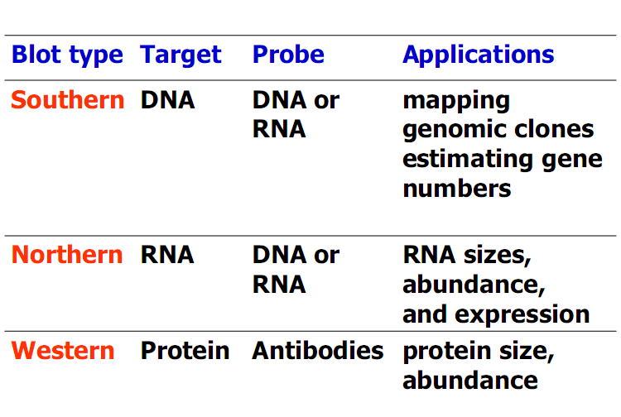

**PCR cycle principles**

①Denaturation: The target DNA (template) is separated into two stands by heating to

95℃

②Primer annealing: The temperature is reduced to around 55℃ to allow the primers to anneal.

③Polymerization (elongation, extension):The temperature is increased to 72℃ for

optimal polymerization step which uses up dNTPsand required Mg++.

**The requirement of PCR cycle**

①Template ：PCR can only be applied ifsome sequence information is known so that

primers can be designed.

②Primers：PCR primers need to be about 18 to 30 nt long and have similar G+C contents so that they anneal to their complementary sequences at similar temperatures.They are designed to anneal on opposite strands of the target sequence.

**Way to PCR optimization**

We can change the annealing temperature and the Mg++ concentration or carry out nested PCR to optimize PCR.

**Two ways for sequencing:**

1. DNA molecules (radioactivellabeled at 5’termini) are subjected to 4 regiments to be

broken preferentially at Gs, CsTs, As, separately.

2. chain-termination method